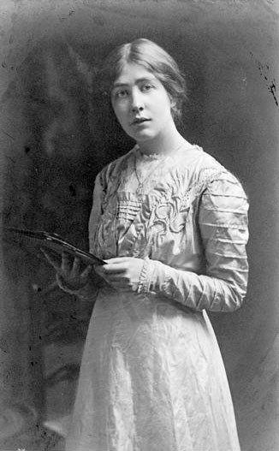
Sylvia Pankhurst, 1909
https://commons.wikimedia.org/wiki/Sylvia_Pankhurst#/media/File:Sylvia_Pankhurst_1909.jpeg
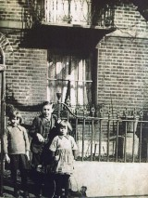 Three of Ellen’s children in Park Walk in c1921. 12 children were born between 1895 and 1916. Copyright author
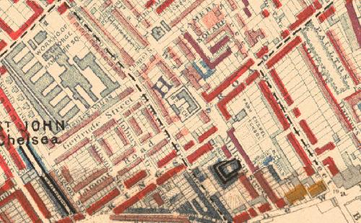 Section of St John’s Parish, Chelsea, from Charles Booth’s Maps Descriptive of London Poverty, 1898-9. As well as Park Walk in the centre, it includes the streets where Ellen lived between 1873 and the 1930s, including Winterton Place, the houses behind Park Walk to the east, including Camera Square, and those south of Park Walk including Millman and Riley Streets. Black represents the ‘lowest class’; dark blue very poor; light blue, poor; purple, mixed; pink, fairly comfortable (Park Walk); red, well to do; yellow, wealthy. Charles Booth Online Archive @London School of Economics and Political Science

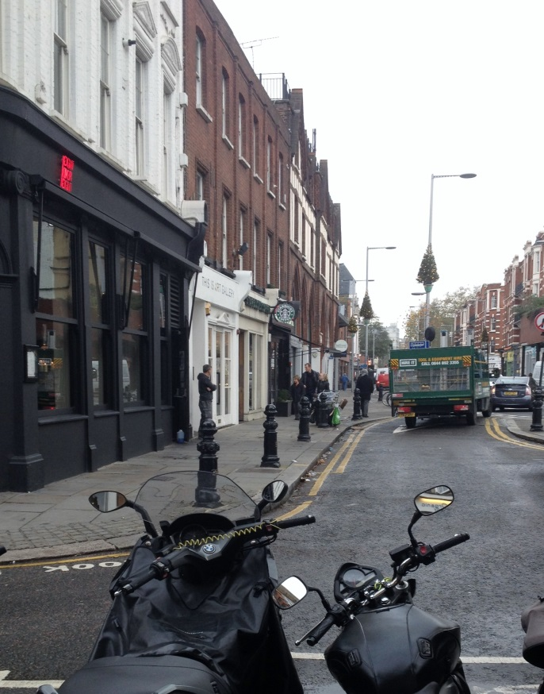
Fulham Road end of Park Walk in 2016. Author’s own

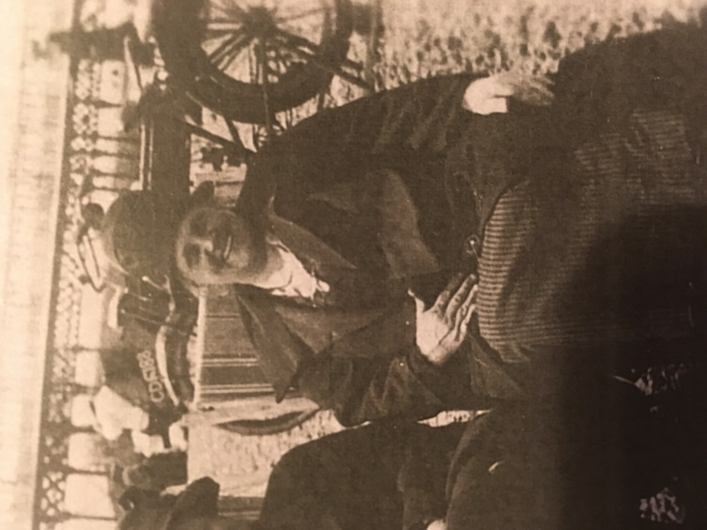
This is the only known photograph of Ellen, taken in the 1930s. Widowed in 1933, she remained at Park Walk, still taking in lodgers and then family, almost until the end of her life in 1946.
Copyright author

